Recording Balgay Park: digital skills and archaeology
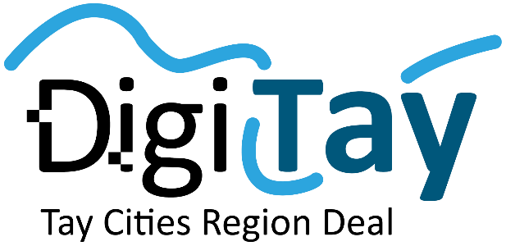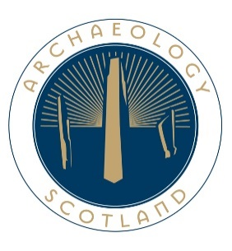

Case Study
Kieran Manchip, Project Officer, Archaeology Scotland

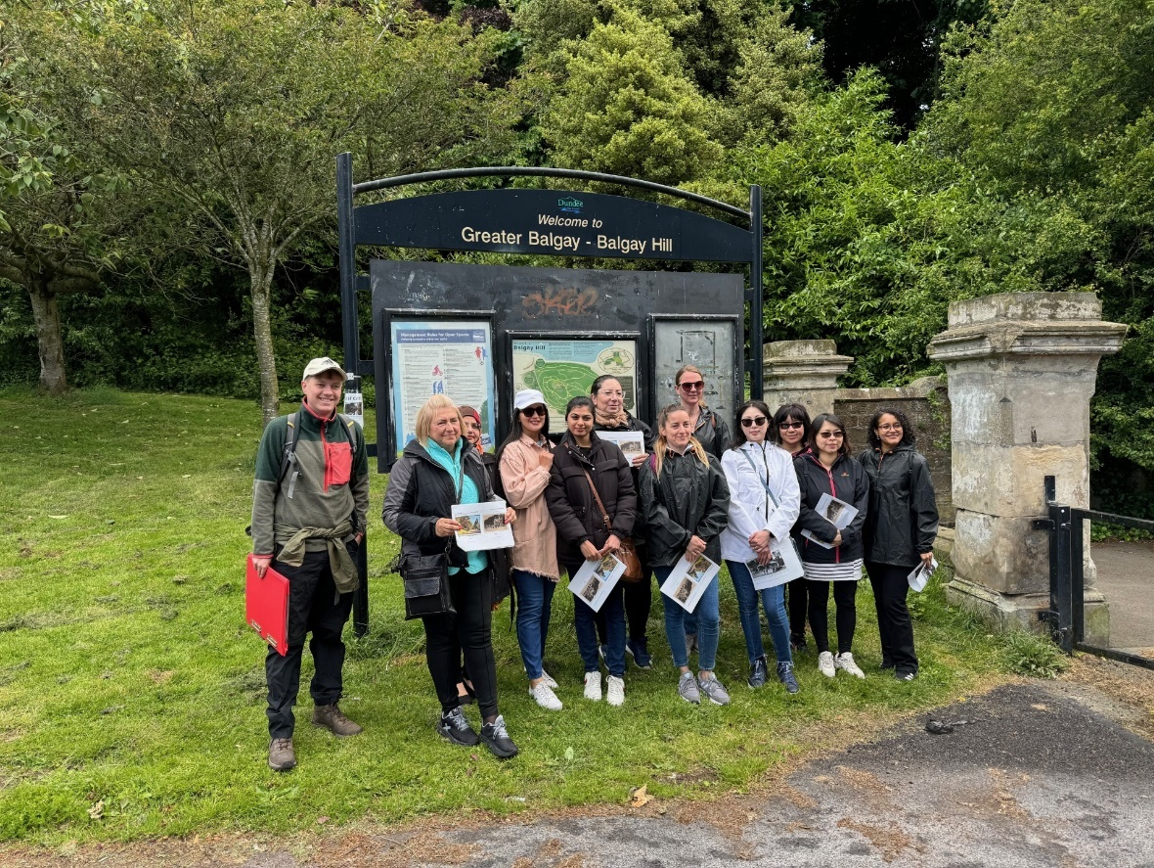

Contents
Introduction 3
Summary 4
Evaluation 8
Conclusion 11
Appendix 1 13
Appendix 2 15

Introduction
Following a successful application to the DigiTay Third Sector Challenge fund Archaeology Scotland (AS) worked with Amina Ohkai (Finding You With Amy) and a group of 12 women from BAME, refugee and asylum seeker backgrounds on a digital skills and archaeology project. The group was made up of women from a Pre-Intermediate ESOL (English for speakers of other languages) level.
This pilot project was designed to help the learners gain new experience, ability and confidence in digital skills through participating and shaping an archaeological recording project. The project worked with women who’s first language was not English and the blend of English language learning around digital skills was an important aspect of the project. There was also a large element of this project that was focussed on improving wellbeing and placemaking and to provide a positive, welcoming and inclusive space for the group to learn and also make social connections and have an enjoyable time.
The course took participants through the story of Dundee’s Balgay Park through researching and recording archaeological sites within the park’s boundaries. These mainly focused on the Victorian elements of the parks story but also touched on the progression from estate to a space for public leisure. Through this process the group learned different digital skills at intermediate level and advanced levels, and how these skills are used in a working environment, in this case an archaeological survey project. For a full breakdown of the project’s schedule please see Appendix 1. Sessions for the majority ran between 10am-2pm with transport and lunch costs covered by the project to assist accessibility.
The project had the following aims:
- To use an archaeology and English language project to help participants learn and practice new Digital Skills
- To increase knowledge and awareness of Scotland/Dundee’s heritage and familiarity of participants new home city (Placemaking)
- To widen participation in Scottish archaeology
- To provide participants with a positive, engaging and inclusive learning experience
- To develop working partnerships across the city and across communities
- Decrease social isolation
The project sought to achieve the following outcomes:
- Work with 12 women from BME and migrant backgrounds
- Work with women from low SMID areas
- Provide learning opportunities to learners in Intermediate and Advanced digital skills
- Leaners will become capable in these skills
- Learners will continue their English language learning
- Learners will research and inform the public about the history and archaeology of Balgay Park
- Learners will build confidence in digital skills and English through an archaeology project to be more ready in employability
- Learners will be signposted to further educational or employability options

Summary
The project began with sessions looking at Desk Based Assessment and how information and data is gathered and added to the project database (gazetteer) prior to the start of fieldwork. One key source material was historic mapping held by the National Library of Scotland (see Fig.1). This focused on Intermediate and Advanced digital skills including understanding the value of data in our context, managing our database through excel and thinking about how data is shown in an archaeological context. While covering more basic skills around internet navigation and research that were unfamiliar to lots of learners due to the language barrier and the fact they were new to Scotland. This also helped the group think about how the project would progress and, crucially what they were interested in.

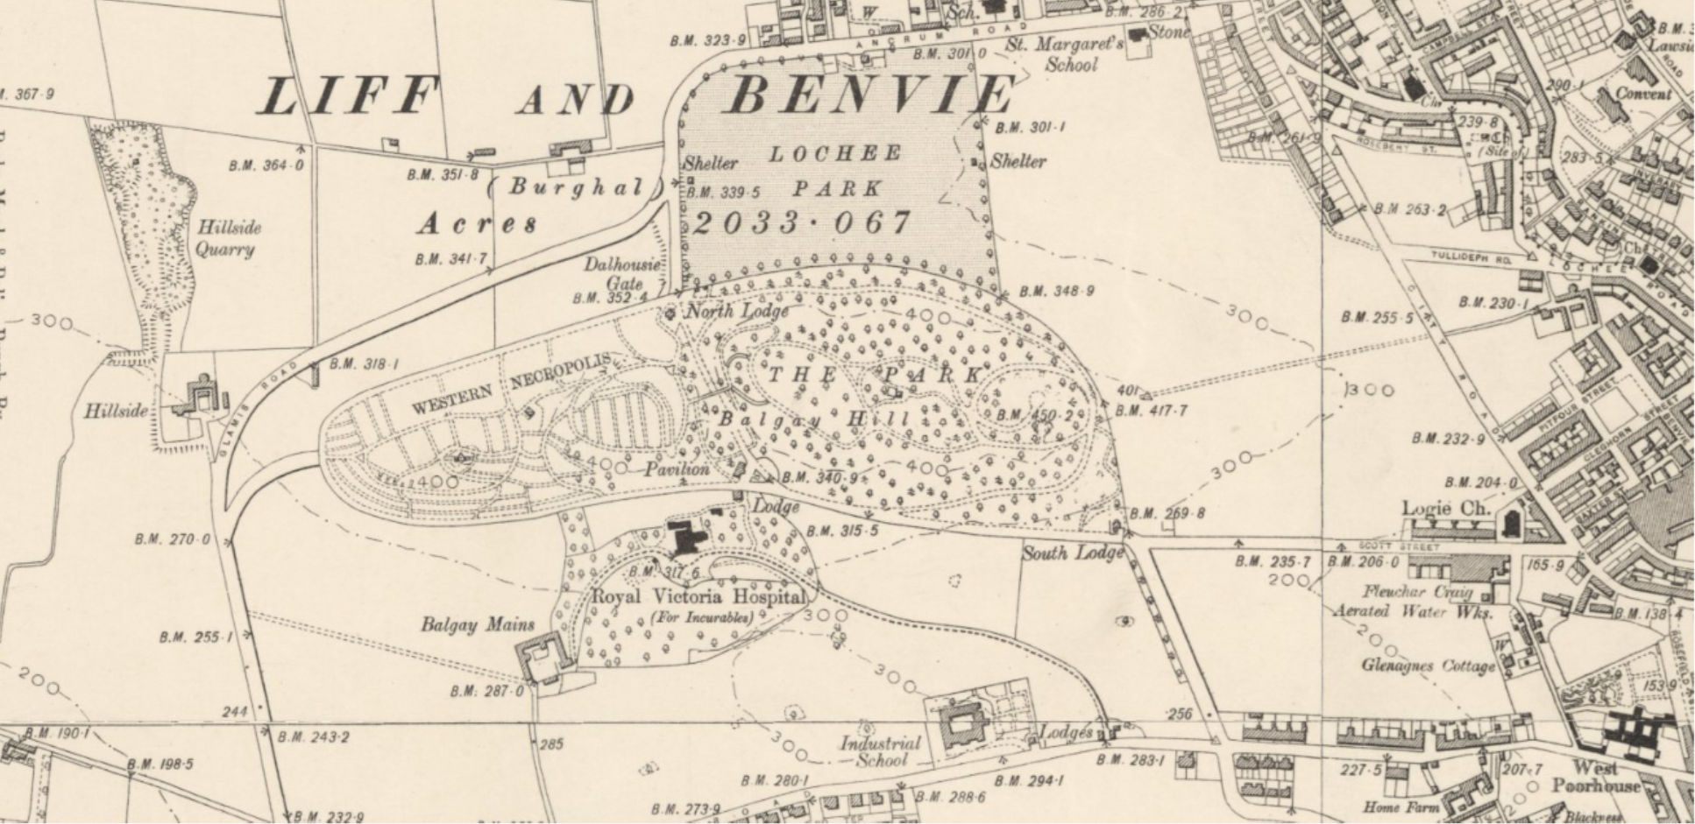
Figure 1: Ordnance Survey 6-Inch to the mile, Second Edition,1888-1913 (Copyright National Library of Scotland)
The project then progressed to the field survey stage where the group went to Balgay Park and worked through an archaeological survey of the historic furniture and aspect of the park. Survey focussed on the Gate and site of the South Lodge before progressing through the Rose Window, relocated baptismal font towards the pavilion and lion fountain before looking at the bridge and features around the site of the North Lodge. The group used digital photography, 3D scanning technology and iPad based recording forms to carry out the survey. With measurements taken with standard tape measures. The purpose of the survey was to record the archaeology of the park, to understand preservation and for the group to engage with the historical fabric of the park and what these features can tell us about the wider story of Dundee. There was also a focus on encouraging conversation, teamwork and active outdoor work and engagement with a historic public space in Dundee. The digital skills included in this phase of the project relate to digital data collection and how that data is sored and how it relates to other aspects of the project. More technical skills included archaeological technical photograph and using 3D scanning technology to create 3d models of features that they recorded.

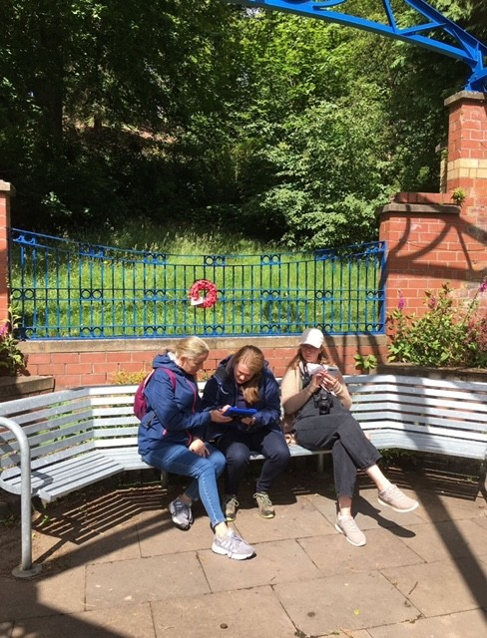

The final section of the project focused on the post-survey aspects of a field survey, or broader archaeological project. Digital skills covered in the first part of this phase of the project centered around managing the project database and adding in the data we collected, a crucial part of any archaeological project. The learners work in groups on the project laptops to take data from the survey forms and to enter them into the gazetteer. This helped the group understand the value of our data, the importance of managing it correctly and what aspects of it are important and how it should be presented. Power Bi was used to illustrate how the group could show the development of the park landscape through time, with an interactive map. We did not have the time to get into QGIS mapping software but what was achieved with the Power BI was more usable and could transfer across other work environments. The group covered Power BI in more depth over a 2-day Power BI course which focused more in depth on the usability of Power BI and it’s use in data analytics and visualization.
As part of this pilot project we also wanted to look at how digital software could be used in leading a group to work through telling the story of their experience on the project. With an emphasis reflecting on what they have learned but what else they got from their experience. To do this we introduced the group to Canva, an online graphic design tool and spent time creating a mind map which brought together the groups thoughts.
We were also able to organize a cyber security session with Professor Lynne Coventry, Director of the CyberQuarter who spoke to the group about cyber security issues that were relevant to them.
The project was rounded off by taking the opportunity to take the group out to two Archaeology Scotland excavations. The first at Newbattle Abbey College, Archaeology Scotland’s base, focused on the excavation of World War Two-era practice trenches. The second excavation was in the Scottish Borders, at Bedrule Castle as part of Archaeology Scotland’s Twelve Towers project. Both trips gave the group more experience of archaeology, the chance to try out excavation, learn how we use other digital skills in that context and importantly the opportunity to see more of the country in which they have found themselves. Positive and welcoming learning experiences are powerful and the chance to improve wellbeing alongside trying out and learning new skills is crucially important to how we envisage building on this pilot project.

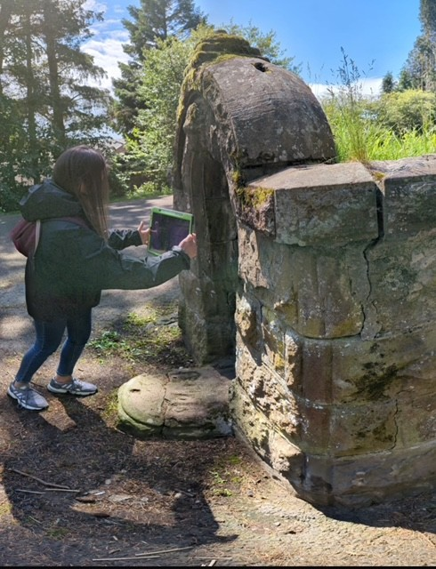

A celebration of the project was held on August 8th and all 12 participants and a volunteer were provided with a Silver Heritage Hero Award for their work on the project. This was an excellent a positive session which celebrated the hard work of the group.
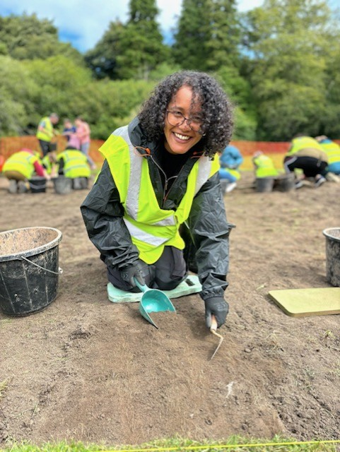

Evaluation

- Work with 12 women from BME and migrant backgrounds
- Work with women from low SMID areas
- Provide learning opportunities to learners in Intermediate and Advanced digital skills
- Leaners will become capable in these skills
- Learners will continue their English language learning
- Learners will research and inform the public about the history and archaeology of Balgay Park
- Learners will build confidence in digital skills and English through an archaeology project to be more ready in employability
- Learners will be signposted to further educational or employability options

All project participants were women who had migrated to Scotland, under various circumstances, 82% of which identified as BAME. Of the participants 58% were based in Dundee, with the remaining 42% in North East Fife. 36% of participants were from areas scored 1 or 2 in the SMID, 46% from areas scored 4 to 5 and the remaining 18% from areas scoring 6 to 10.
Evaluation on the project’s progress and learners experience was taken after the field survey element of the project to provide information on how field survey works in practice as a mode of introducing a group to archaeological survey and digital data collection.

Quantitative:
- 100% of participants said they would like to do more survey.
- 100% of participants agreed that survey sessions helped their English.
- 66.7% of participants rated the digital; field survey experience as very good.

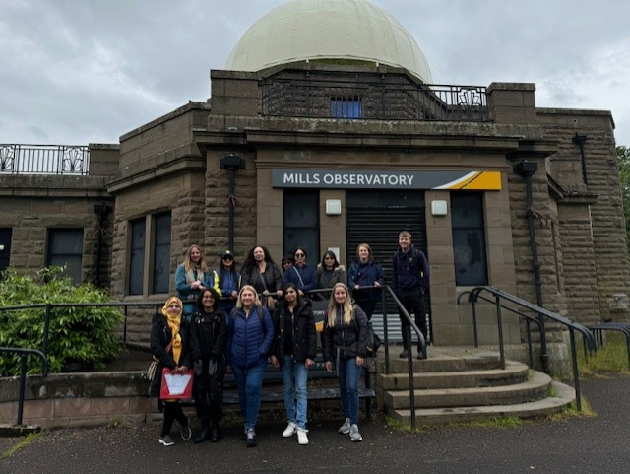

What did you learn?
- “I learned a lot about history of Balgay Park. I discovered a lot of new interesting facts about park. Learn- collect informations details , measuring, scanning. A lot of new words.”
- I learnt about the history of Balgay Park and how this change with passage of time”
- “digital scanner, catalouge, online maps, a lot of history about Balgay park, new interesting facts about park, many new words"

What did you enjoy the most?
- “I enjoyed that was in the park and we could see in real place what we learn about. I learn a lot about Balgay park history what makes me more interesting about parks and history of Dundee. I enjoy learn how get informatons like measuring and scanning.”

- “Firstly I love being outdoors and secondly knowing how the park come about changes my whole experience of going to the parks. I'll always look with a searching eye.”

- “Work in the groups visit historical and beautiful places in Balgay”

Evaluation was also conducted at the end of the project (due to staffing issues it was not completed after the Power BI course in late August).
Quantitative: Particpants were asked to score from 1-5 on their confidence/ability in certain aspects of the project, for example “Creating 3D model”.

Qualitative: Q: “What have you enjoyed the most?”
A:
- “Working in the groups. Having conversation with people from different countries. Visiting Balgay Park and understanding the history of the places in there. And the most Enjoyable one was going to Edinburgh.”
- “I really enjoy seeing the historical places in Balgay Park like the bridge and trip to Newbattle Abbey Collegeand seeing historical places in the college.”
- “Trip to Newbattle Abbey College, seeing historical things in Balgay Park, taking pictures”
- It was a very informative and knowledgeful course. Its very interesting. Chance to meet different people of different countries and different type of peoples - of differnet cultures. I imporved my speaking level.”
- “I enjoy learing about archaeology and excavation, and I enjoy working in a team.”
- “Meet new people, dig, travelling to new place”
- “Very good conversation. I met some great new people, lots of information about 3D modelling, historic maps, digital site survey and I discovered many new places and objects”
- “I enjoyed the most 3D modelling and archaeological excavation. Exploring historic maps”
- “Its very informative and knowledgeful course. Especially my english improved and increased confidence. I also have knowledge about archaeology and information about historic places. How we save our analysis and data. Everything is very good and really enjoyed. :)”
- “I enjoyed every part of the course. This course encourages me to discover a lot of new interesting facts about Dundee and about my childhood place. I am better with exploring maps and photos now. Course providers were very professional we work in very good atmosphere.”
- “I have enjoyed going on adventures with a group of kind, funny, intelligent and enthusiastic people that made me become more knowledgeable and confident. I am grateful that I was able to learn invaluable information I the company of such wonderful people. Being able to learn in safe and encouragin environment has been a priviledge. I refreshed my statistical knowledge with the help of Mrs Inez as well as expanding my software options with an introduction to Power Bi. Surveying Balgay park felt like being a detective and it was fun/enjoyable/life changing getting to decode a piece of my home 10/10 experience.” – volunteer
- “I enjoyed understanding te whole process of archaeology - how to read a map, how to catalouge found items. And im interest with everyone involved in this project. Always trying to understand what we say without belittleing it. Thank you for that”
- “I enjoyed visting Balgay park, doing surveys of artefacts like the rose window and the bridge. I enjoyed the dig at Newbatle Abbey College”

Conclusion

Overall, this pilot project was a success, in terms of the digital skills provision, the archaeological learning and English language learning. With other desired outcomes relating to improved wellbeing and sharing the story of Balgay Park also proving successful. Engagement with all aspects of the project was excellent, with the good interest and engagement with the archaeology aspects helping the group through the digital skills and seeing how these skills are applicable in a ‘workplace’ environment.
The evaluation shows that the project achieved success along it’s key outcomes. To begin with all learners indicated improvement along the key learning outcomes of digital skills, English and archaeology. With feedback indicating they enjoyed the social aspect and working in a team outdoors. The unexpected opportunity to take the group and some of their family members on the excavation trips was a great way to sound of the project both socially for the group but they also helped to consolidate the archaeological learning aspect and to show different ways in which technology is playing more of a role in archaeology.
Discussions are ongoing with Skills Development Scotland to set dates for the participants to access support as the project finishes.
Some recommendations on how we may modify this pilot are as follows:
- Longer field survey sessions to accommodate lunch break
- A greater variety of sites, maybe taking in the Tayside countryside and sites the group would struggle to access otherwise
- Develop connections/working relationship with Data Understood – more specialist delivery of Digital Skills
- Greater engagement with wider public, for example an exhibition
- Archaeological excavation

Appendix 1
Project Schedule
Session Number | Date | Activity | Venue | Staff
1 | 23rd May  10am-2pm | Introduction  - Baseline evaluation (worksheet)  - Introduction to archaeology through rubbish game, object handling and timeline activity (can use finds from Bonchester?)  - Project Introduction: what will we do  - Learning Outcomes  - Balgay Park – what we know, what we want to find out  - CANMORE?  - Maps | Abertay Uni | AO,KM
2 | 30th May | Desk Based Assessment Workshop  - Digital Skills- database creation - Gazeteer  Canmore/past map and entering in the information  - Online research- link more to Intermediate Skills  - Sites to Focus on- for map and info graphic  Can Use iPads if laptops now ready | Abertay Uni | KM, AO
3 | 6th June | Site Visit and recording training – digital skills focus and begin survey | Balgay Park | AO,KM, IH
4 | 13th June | Online Feedback Session - Database work 1hr | Online | AO, KM
5 | 20th June | Break Week
6 | 27th June Thu | Power Bi introduction and Mindset Activities (AO) | Abertay | AO
7 | 4th July | Survey | Balgay Park | KM, AO
8 | 11th July | Survey | Balgay Park | AO, KM
9 | 18th July | Database Work and Telling the Story - Infographic | Abertay Uni | AO, KM, BB
10 | 25th July | Database Work and Telling the Story Infographic | Abertay Uni | AO, KM, BB
11 | 1st August | Database Work | Abertay Uni | AO,KM, BB
12 | 7th August | Visit to Newbattle Excavation | Newbattle Abbey College | AO, KM and Archaeology Scotland Big Dig Excavation Team
13 | 8th August | Finalize the end-product  Celebration Event – Heritage Hero Awards | Abertay Uni | AO,KM, BB, BM
14 | 20th August | Power Bi – Data Understood | Abertay Uni | AO, IH
15 | 27th August | Power Bi - Data Understood | Abertay Uni | AO, IH
16 |  | Python course with Data Understood | Abertay Uni | AO,IK

Appendix 2
Telling the Story Mind Map
